

**MGM’s POLYTECHNIC, AURANGABAD**

**2020-2021**

Micro Project Report

On

**“WORKING MODEL OF HYDROELECTRIC POWER PLANT”**

Submitted in partial fulfillment for ‘I’ Scheme fifth semester of

**Diploma in**

**MECHANICALENGINEERING**

**By**

**MOHAMMED SAAD SAYYED ( 1915010276 )**

Under the guidance of

**Prof. Siddiqui Javed**

(Lecturer in Mechanical Engineering)

***In Pursuit of Excellence***



[**Maharashtra State Board of Technical Education, Mumbai**](http://msbte.org.in/)

**(Autonomous) (ISO-9001-2008) (ISO/IEC 27001:2013)**



**Maharashtra State**

**Board of Technical Education, Mumbai**

**Certificate of Completion**

This is to certify that**, MOHAMMED SAAD SAYYED** with Enrollment No: **1915010276 ,** have successfully completed their Micro-Project entitled **“WORKING MODEL HYDROELECTRIC POWER PLANT”** in the Course/Subject of **"22566 - Power Plant Engineering (Elective)”**in the fifth semester during thier tenure of completing the Diploma programme in **Mechanical Engineering** From **MGM's Polytechnic** institute with institute code **1501.**

**Prof. Siddiqui Javed Prof. Bhalekar B.D**

**DEAN HOD**

Mechanical Engineering Mechanical Engineering

**Dr. B. M. Patil**

**Principal**

**ACKNOWLEDGEMENT**

I would like to express my/our gratitude towards guide **Prof. Siddiqui Javed** for the useful comments, remarks and for giving his valuable guidance and inspiration throughout the learning process of this report.

Furthermore, I would like to thank our **Prof. B. D. Bhalekar (HOD)** for making available all the facilities for the successful completion of this work and other staff members of **Mechanical Engineering Department** for their valuable help.

It is with humble gratitude & sense of indebtedness; I thank my respected and esteemed **Dr. B. M. Patil (Principal)** for his valuable guidance, suggestion and constant support which lead towards successful completion of this work.

###### Date:5 / 12 /2020

###### Place: Aurangabad

**MOHAMMED SAAD SAYYED ( 1915010276 )**

**INDEX**

|  |  |  |
| --- | --- | --- |
| **Sr. No.** | **Content** | **Page No.** |
| **Micro-Project Proposal (ANNEXURE-I)** | |  |
| 1.0 | Aims/Benefits of the Micro-Project | 4 |
| 2.0 | Course Outcomes Addressed | 4 |
| 3.0 | Proposed Methodology | 4 |
| 4.0 | Action Plan | 4 |
| 5.0 | Resources Required | 5 |
|  |  |  |
| **Micro-Project Report (ANNEXURE-II)** | |  |
| 1.0 | Rationale | 6 |
| 2.0 | Aims/Benefits of the Micro-Project | 6 |
| 3.0 | Course Outcomes Achieved | 6 |
| 4.0 | Literature Review | 6 |
| 5.0 | Actual Methodology Followed | 15 |
| 6.0 | Actual Resources Used | 15 |
| 7.0 | Outputs of the Micro-Projects | 16 |
| 8.0 | Skill Developed / Learning outcomes of this Micro-Project | 16 |
| 9.0 | Applications of this Micro-Project | 16 |

**Annexure – I**

**Micro-Project Proposal**

**WORKING MODEL OF HYDROELECTRIC POWER PLANT**

1. **Aims/Benefits of the Micro-Project**

Hydropower plants capture the energy of falling water to generate electricity. A turbine converts the kinetic energy of falling water into mechanical energy. Then a generator converts the mechanical energy from the turbine into electrical energy.

**2.0 Course Outcomes Addressed**

* Explain energy conversion in the given power plant.
* Identify elements of the given Hydro, Gas, Diesel power plant(s).
* Explain preventive procedure of the given power plants.
* Explain predictive maintenance procedure of the given power plants.

**3.0 Proposed Methodology**

1. We finalize micro project team.
2. We finalize topic for micro project working model of hydropower plant
3. We prepare certificate and proposal of report.
4. Then we will collect information based on working model of hydropower plant
5. We will prepare a Model on working model of hydropower plant
6. And we will make report based on micro project.
7. Then at last we will show a model on working of hydropower plant

**4.0 Action Plan**

|  |  |  |  |  |
| --- | --- | --- | --- | --- |
| **S. No.** | **Details of activity** | **Planned Start date** | **Planned Finish date** | **Name of Responsible Team Members** |
|  | Finalization of Micro Project Team | 15/11/2021 | 17/11/2021 | Sayyed Saad , Amey Shahane, Veersingh Pardeshi |
|  | Finalization of Topic | 17/11/2021 | 19/11/2021 |
|  | Literature Survey | 20/11/2021 | 21/11/2021 | Sayyed Saad , Amey Shahane, Veersingh Pardeshi |
|  | Submission of Micro-Project Proposal (ANNEXURE-I) | 21/11/2021 | 22/11/2021 | Sayyed Saad , Amey Shahane, Veersingh Pardeshi |
|  | Proposed Methodology | 22/11/2021 | 23/11/2021 | Sayyed Saad , Amey Shahane, Veersingh Pardeshi |
|  | Collecting Resources Required (raw material) | 23/11/2021 | 23/11/2021 | Sayyed Saad , Amey Shahane, Veersingh Pardeshi |
|  | Making of Model | 23/11/2021 | 24/11/2021 | Sayyed Saad , Amey Shahane, Veersingh Pardeshi |
|  | Submission of Micro-Project Report (ANNEXURE-II) | 25/11/2021 | 26/11/2021 | Sayyed Saad , Amey Shahane, Veersingh Pardeshi |
|  | Presentation of Model to Institute | 5/12/2021 | 6/12/2021 | Sayyed Saad , Amey Shahane, Veersingh Pardeshi |

**5.0 Resources Required**

|  |  |  |  |  |
| --- | --- | --- | --- | --- |
| **S. No.** | **Name of Resource/material** | **Specifications** | **Qty.** | **Remarks** |
|  | Plastic container | As dam | 1 | 500ml |
| 2 | Pvc pipes | As penstock | 1 | ½ inch |
| 3 | Pvc elbow | As surge tank | 1 | ½ inch |
| 4 | valve | As gate | 1 | 1 way |
| 5 | Nozzle | As pressure nozzle | 1 | Normal |
| 6 | DC Motor | As generator | 1 | Toy motor |
| 7 | LED | As street lamp | 5 | 1volt |
| 8 | Impeller | To give rotation to shaft | 1 | Home made |
| 9 | Wires | For electric connection | 10 cm | 2mm |

**Name of Team Members Roll No’s:**

1. MOHAMMED SAAD SAYYED 22114

**\*\*\*\*\*\*\*\*\*\*\*\*\***

**Annexure – II**

**Micro-Project Report**

**WORKING MODEL OF HYDROELECTRIC POWER PLANT**

* 1. **Rationale**

"A hydraulic turbine converts the energy of flowing water into mechanical energy. A hydroelectric generator converts this mechanical energy into electricity. The operation of a generator is based on the principles discovered by Faraday. He found that when a magnet is moved past a conductor, it causes electricity to flow. In a large generator, electromagnets are made by circulating direct current through loops of wire wound around stacks of magnetic steel laminations. These are called field poles, and are mounted on the perimeter of the rotor. The rotor is attached to the turbine shaft, and rotates at a fixed speed. When the rotor turns, it causes the field poles (the electromagnets) to move past the conductors mounted in the stator. This, in turn, causes electricity to flow and a voltage to develop at the generator output terminals."

**2.0 Aims/Benefits of the Micro-Project:**

* Identify various components used in Hydroelectric power plant using models, charts, simulated and real videos.
* Maintain various components of Hydroelectric power plant using models, charts, simulated and real videos.

**3.0 Course Outcomes Achieved**

* Explain energy conversion in the given power plant.
* Identify elements of the given Hydro, Gas, Diesel power plant(s).
* Explain preventive procedure of the given power plants.
* Explain predictive maintenance procedure of the given power plants.

**4.0 Literature Review**

Several models of hydropower generation were investigated by scientists. The existing models depend upon the requirement involved in the study. Some of these models were simply analytical while others were constructed from robust system models showing the dynamic characteristics. IEEE working group/committee [3, 4] have shown various models of hydro plant and techniques used to control the generation of power. [5] describes an approximation of hydro-turbine transfer function to a second order for multi-machine stability studies. Similarly, Qijuan et al. [6] introduced a novel model of hydro turbine generating set which uses recursive least square estimation algorithm. This model is dynamic. In reality, the performance of hydro-turbine is mainly determined by the parameters of the water been supplied to the turbine. According to Singh & al. (2011), [7], some of these parameters include the effects of water inertia, water compressibility, pipe wall elasticity in penstock. The effect of water inertia is to ensure that changes in turbine flow do normally lag behind changes in turbine gate opening for a smooth operation. On the other hand, the effect of elasticity introduces some element of pressure and flow in the pipe, a phenomenon known as “water hammer”, [7]. Other parameters of the flowing water also affect the flow of water

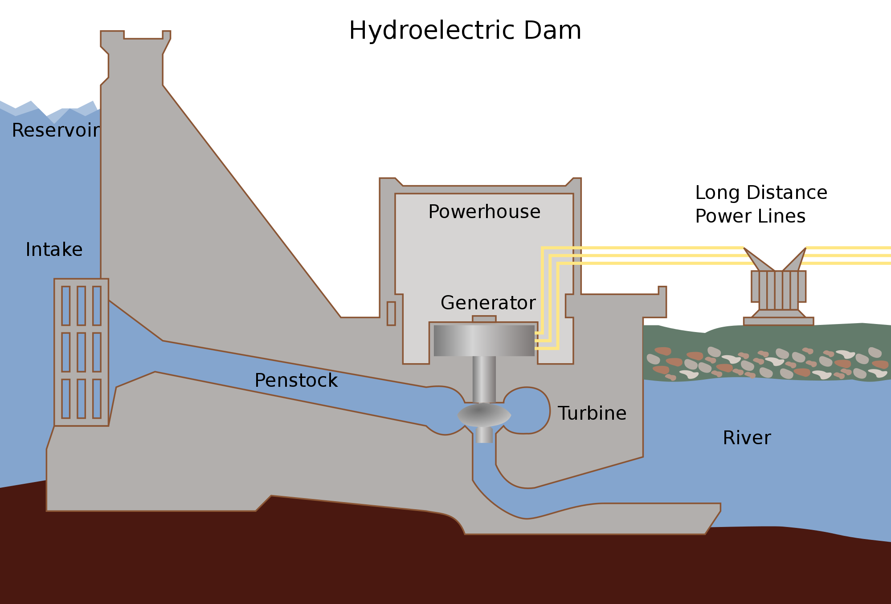

## What is Hydroelectric Power Plant

Hydroelectric Power Plant is a system in dams and works by obstructing the river flow which causes to increase and store water in the Dams. This is Potential Energy. The water is made to fall from a height which constitutes Kinetic Energy. This Kinetic Energy is then converted to Mechanical Energy by the Turbines. Generator is responsible in converting this Mechanical Energy from the Turbine into Electrical Energy.

**[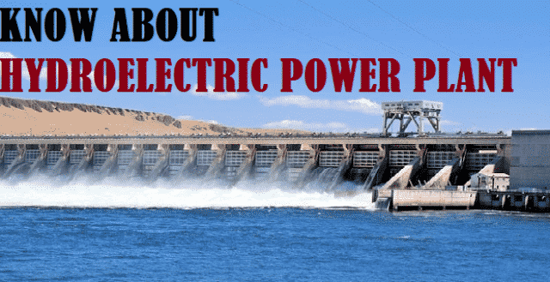](https://i0.wp.com/electricalfundablog.com/wp-content/uploads/2020/02/Intro-to-Hydroelectric-Power-Plant.png?ssl=1)**

**Fig. 1 – Introduction to Hydroelectric Power Plant**

Hydroelectric Power Plants generates electricity for home consumption or business needs. The flexibility of generating the electricity usually is either in a large scale or in a smaller scale depending on the usage. In 1879, the first commercial Hydroelectric Power Plant was built at Niagara Falls. Although every passing year, there has been continuous improvements  doing rounds for safer and efficient utilization.

[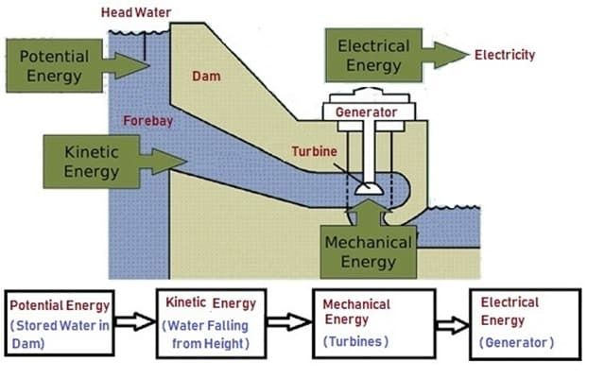](https://i0.wp.com/electricalfundablog.com/wp-content/uploads/2020/02/New-Hydro-1.jpg?ssl=1)

**Fig. 2 – Basic Block Diagram of Energy Conversion in Hydroelectric Power Plant**

## Classification of Hydroelectric Power Plant

The classification of Hydroelectric Power Plant is done with various criteria. Either by the storage capacity and the water flow or through the technologies applied. Let us go through both the criteria.

Hydroelectric Power Plant is classified based on:

* Availability of Water Flow
* Availability of Water Head
* According to Load Type

**[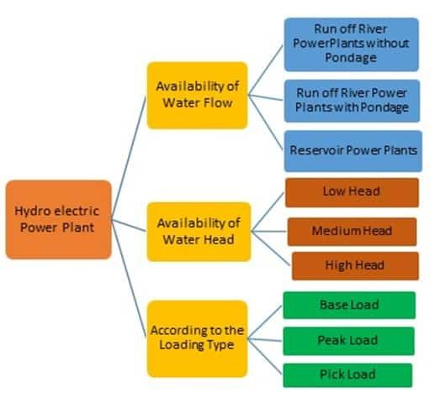](https://i1.wp.com/electricalfundablog.com/wp-content/uploads/2020/02/Classification-of-Hydroelectric-Power-Plant.jpg?ssl=1)Fig. 3 – Classification of Hydroelectric Power Plant**

### Classification of Hydroelectric Power Plant Based on Availability of Water Flow

This is of three types. They are:

* Run-Off- River Power Plant without Pondage
* Run-Off-River Power Plants with Pondage
* Reservoirs Power Plant

#### Run Off River Power Plant without Pondage

In this type, the water availability plays a very important role. Here the Power Plant works only when there is enough water since there is no storage or pondage facility available. The facility is placed where there is connectivity directly to the river or pond. The development cost of this plant is cheaper compared to the full time plant. The objective of such a plant is to utilize excessive water during the flood situation or the rainy season.

#### Run Off River Power Plants with Pondage

The pond is used as storage for the water along with increasing its capacity. This type of plant is used mostly during the fluctuating load period depending on the pondage size. These types of Power Plants save the conservation of coal.

#### Reservoirs Power Plant

Reservoir Power Plants are across the globe in maximum numbers**.**In this, the water is stored behind the dam which is available throughout the year. This Power Plant is used during the peak consumption of electricity as well as during the base period.

### Classification of Hydroelectric Power Plant Based on Availability of Water Head

They are of 3 types:

* Low Head Hydroelectric Power Plant
* Medium Head Hydroelectric Power Plant
* High Head Hydroelectric Power Plant

#### Low Head Hydroelectric Power Plant

The Propeller Turbines are used for the Low Head Power Plant. The dam is placed just ahead of the water resources such as the pond or the river. The water level is directed to the Turbine through the Penstock.

[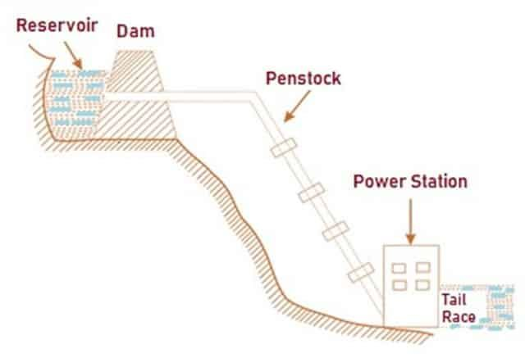](https://i0.wp.com/electricalfundablog.com/wp-content/uploads/2020/02/Low-Head-Power-Plant.jpg?ssl=1)

**Fig. 4 – Working of Low Head Power Plant**

#### Medium Head Hydroelectric Power Plant

This power plant has a Forebay created mainly to store water. They are the storage tank which taps the river water which goes to the Turbine through the Penstock. The Forebay serves as a surge tank.

[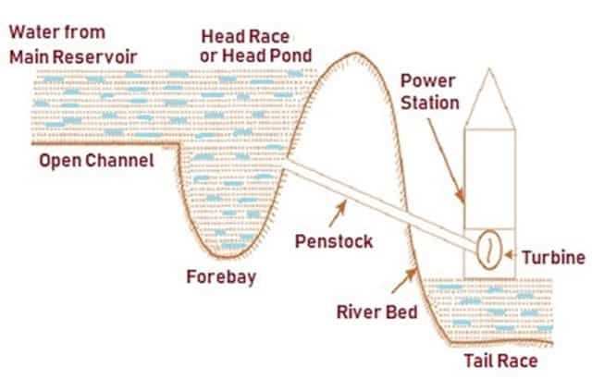](https://i2.wp.com/electricalfundablog.com/wp-content/uploads/2020/02/Medium-head.jpg?ssl=1)

**Fig. 5 – Working of Medium Head Power Plant**

#### High Head Hydroelectric Power Plant

The dam constructed usually is for maximum reserve water level. The Surge tank stores the additional water which would be required during the peak load time with the supply to the Turbine.

[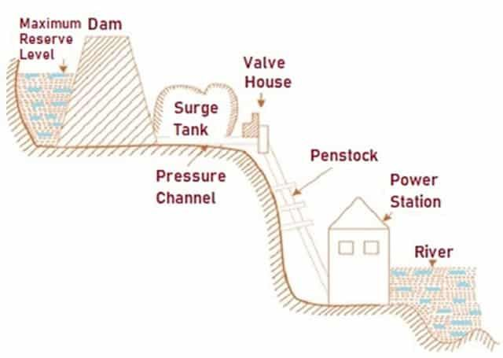](https://i1.wp.com/electricalfundablog.com/wp-content/uploads/2020/02/High-head.jpg?ssl=1)

**Fig. 6 – Working of High Head Power Plant**

### Classification of Hydroelectric Power Plant Based on Load Supply

There are 3 types of load supply types mentioned below:

* Base Load Supply
* Peak Load Supply
* Pumped Storage

#### Base Load Supply

This type of Power Plant is a large capacity plant providing extensive supply. There is a Base portion to the load curve of the Power Plant. This sort of Power Plant is suitable for the constant load.

#### Peak Load Supply

As the name suggests, the Power Plant is suitable for the peak load curve. This needs a big capacity water storage facility.

#### Pumped Storage

The demand for the electricity is never on a decline. However, the consumption changes during the day and the night with the use of electricity. To match this demand the pumped storage method is utilized. Here, the water is kept in reserve for the high demand periods which comes from the Turbines to back up a storage pool which is situated above the power plant. This is done during the night when the consumption is low. The water is let back out when the demand is high usually during the day.

## How does Hydro Electric Power Plant Work

The concept of how the Hydroelectric Power Plant works is straightforward and simple, however the operation of the same is quite complex. The Plant is usually custom made according to the plant priority and capacity. They are usually relied on the monitor, the control system and the improvement conditions to the smooth operation of the plant.

Complex systems like the monitoring, control and improvement of conditions which ensures the smooth running of the Power Plant. The moving parts go through a rigorous wear and tear which is minimized by the bearing and the lubricating systems. The hydraulic systems are in charge of opening and closing the pen-stock gates. To keep the temperatures in control, the cooling systems are monitored to prevent overheating of the transformers, the cables and so on.

[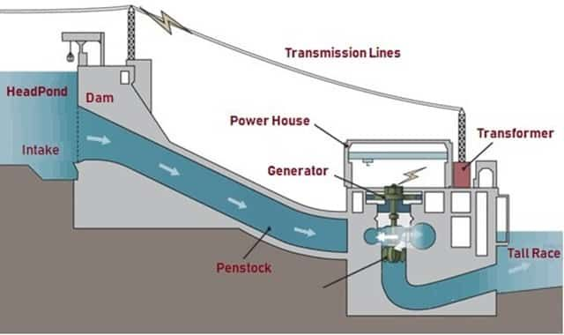](https://i1.wp.com/electricalfundablog.com/wp-content/uploads/2020/02/Working-Of-Hydro.jpg?ssl=1)

**Fig. 7 – Operation of Hydroelectric Power Plant**

The Hydro Electric Power Plant consists of a Dam, Reservoir, Turbines and Generators. The main concept is that the reservoir stores the water (fuel) and under controlled conditions, the water is fed as input to the Turbines. This also serves as a Decanter.

The water from the Reservoir is transferred through the Dam Gates and the Pen-stock to the Turbines. With all the water processing taking place, there is a Filtering system which ensures a clean and relatively free of suspended solids which could damage the Turbine’s blades. The Hydraulic systems play an important role, consisting of the governor (controls the flow of water through the turbine), brakes, gates which help in the inflow and the outflow of the water to the reservoir.

The conversion of the Kinetic energy into Mechanical energy from the movement of the water fall is done through the Turbine. The Turbines are connected from the Shaft to the Rotor of the generator which converts to the Electricity from the mechanical energy. Turbines are usually custom made according to the needs of the Hydro Electric Power Plant.

## Applications of Hydro Electric Power Plant

The applications of Hydroelectric Power Plant include:

* Unlike other source of energy, Hydroelectric Power Plant helps in generating Eco Friendly Energy.
* They help in creating Recreational Facilities.
* It also helps in Flood Risk Management.
* The water from the dam is used for Agricultural Irrigation Facility.
* It helps in generating revenue as the location of the Plant creates a tourist spot.

## Advantages of Hydro Electric Power Plant

The advantages of Hydroelectric Power Plant are:

* Supply of electric power is maintained consistently.
* The water can be stored and used when the demand is high.
* The longevity of the dams is high which helps in generating electricity at lower cost.
* While constructing the dam, a lake is formed from the reserve water. This can be converted into a tourist attraction or for water sports.
* The Hydroelectric Power generation is renewable and is eco-friendly.

## Disadvantages of Hydro Electric Power Plant

The disadvantages of Hydroelectric Power Plant are:

* The constructions of dams are very expensive since it’s in a large scale and has to be well protected. Any slight damage will create a huge destruction not just in the dam but also around its vicinity.
* The returns on the cost invested on the dams can only be got after a long time. Hence the dam has to be operational for many years to be profitable.
* At the time of building a hydroelectric power dams, the habitants in and around the area are moved out of their houses and the business. This creates a disturbance.
* Construction of these dams creates geological damages. Eg, During the construction of Hoover Dam in USA, there was a lot of damages through earthquake and depression on the earth’s surface.
* Dam’s create a kind of disturbance with neighboring states or countries which connects the rivers. Since the dams are created by blocking the river which creates an irregular supply of water.

**List of Hydroelectric Power Plants in India**

States River Hydroelectric Power Plant

* Andhra Pradesh Krishna Nagarjunasagar Hydro Electric Power plant
* Andhra Pradesh Krishna Srisailam Hydro Electric Power plant
* Andhra Pradesh, Orissa Machkund Machkund Hydro Electric Power plant
* Gujarat Narmada Sardar Sarovar Hydro Electric Power plant
* Himachal Pradesh Baira Baira-Siul Hydroelectric Power plant
* Himachal Pradesh Sutlej Bhakra Nangal Hydroelectric Power plant
* Himachal Pradesh Beas Dehar Hydroelectric Power plant
* Himachal Pradesh Sutlej Nathpa Jhakri Hydroelectric Power plant
* Jammu and Kashmir Chenab Salal Hydro Electric Power plant

**Facts about Hydroelectric Power plants in India**

* The Koyna Hydroelectric Project is the largest completed hydroelectric power plant in India. It has a power capacity of 1960 MW.
* The first hydroelectric power station was the Sidrapong hydroelectric power station.
* Tehri Hydro Electric Power plant is the highest hydroelectric power project in the country, also Tehri Dam is the tallest one in India. Now, NTPC has taken over the project (Since 2019).
* Srisailam Hydro Power Plant is the third largest working project in India.
* Nathpa Jhakri Hydroelectric Power Plant is the biggest underground hydroelectric power project in the country.
* Sardar Sarovar Dam is the world’s second-largest concrete dam. Get the list of dams in India at the linked article**.**

Hydropower plants range in size from small systems suitable for a single home or village to large projects producing electricity for utilities. Learn more about the sizes of hydropower plants.

**5.0 Actual Methodology Followed**

1. We finalize a micro project team.
2. We finalize micro project topic based on syllabus.
3. We prepared proposal of micro project.
4. We distributed work of micro project into 3 team members as per their skills.
5. Collection of information/details required to was done by Saad Sayyed
6. Making of report was done by Saad Sayyed
7. Compose, typing and drafting of model done by amey shahane
8. Literature review is done by Sayyed Saad

**6.0 Actual Resources Used**

|  |  |  |  |  |
| --- | --- | --- | --- | --- |
| **S. No.** | **Name of Resource/material** | **Specifications** | **Qty.** | **Remarks** |
|  | Plastic container | As dam | 1 | 500ml |
| 2 | Pvc pipes | As penstock | 1 | ½ inch |
| 3 | Pvc elbow | As surge tank | 1 | ½ inch |
| 4 | valve | As gate | 1 | 1 way |
| 5 | Nozzle | As pressure nozzle | 1 | Normal |

* 1. **Outputs of the Micro-Projects**

However, in reality, the rise in excitation voltage is also limited to the capacity of the existing source of supply. In case of this simulation, the rise in excitation voltage was about 10 pu which is actually very difficult to attain in real conditions. An additional rise in speed can help to improve upon the problem but the control system established in the simulation showed that the rise in speed were negligible. It is henceforth recommended that the governor control systems should be improved upon with modern control techniques such as fuzzy logic and this should be embedded in future models of hydropower plants.

**8.0 Skill Developed / Learning outcomes of this Micro-Project**

We developed skills as follows:

* **Communication skills.**
* **Leadership skills.**
* **Team management skills.**
* **Time management skills.**
* **Problem-solving skills.**
* **Technical writing skills.**
* **Reporting skills.**
* **Adaptability.**
* **Project management methodologies.**

**\*\*\*\*\*\*\*\*\*\*\*\*\*\***